*Florida International University*

*School of Computing and Information Sciences*

CIS 4911 - Senior Capstone Project

Software Engineering Focus

Feature Document

User Story #**830**

**Team Member:**

Jorge Nonell. Eric Aguiar, Alex Karpis, Chris Naranjo

**Product Owner(s)**:

Francisco Ortega

**Mentor(s)**:

Francisco Ortega

**Instructor**: Masoud Sadjadi

**User Story** Layer Visualization Feature

* **As a Developer I would like to** have the ability to work with an object oriented Layer Visualization Feature **so that I** can take advantage of reusable objects for future UI features and to easier debug any future bugs.

Acceptance Criteria

* Refactor to work with new Menu/Canvas system
* Refactor Layer Visualization Feature into its own class
* Works correctly in the same way it used to

**Use Case** #**830 – Redesign UI to be object oriented**

Use Case:

Rewrite the Layer Visualization Feature

Details:

Actor: Developer

Pre-conditions:

* Project working on VS2015
* Program Running

Description:

* Use case begins anytime a developer needs to interact with the Layer Visualization Feature code. This will affect the developers efficiency in working with the Layer Visualization.
* The user story ends when the developer can interact with the Layer Visualization Feature in an easier and more efficient manner than before.

Post-conditions:

A developer can easier understand and add additional features to the Layer Visualization Feature.

Decision Support:

Frequency: Often. Developers need to easily understand code

Criticality: High. Enables developers to work more efficiently

Risk:Low. Team members need to get used to new structure

Constraints:

Reliability: Very Reliable.

Performance: No performance improvements

Supportability:

Must work with ACER Multi Touch, Leap, RealSense and Eyex

Modification History:

Owner: Eric Aguiar

Initiation date: 07/17/2016

Date last modified: 07/18/2016

**Use Case Diagram**

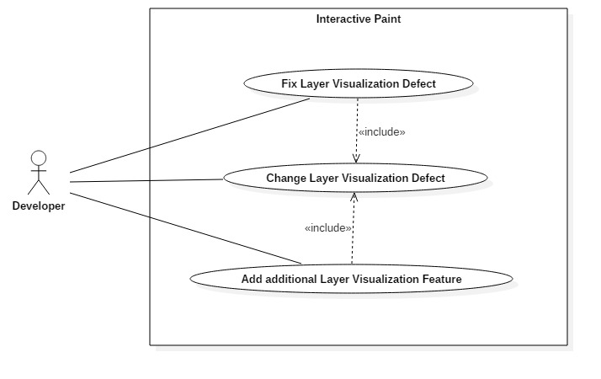

**Sequence Diagram**  
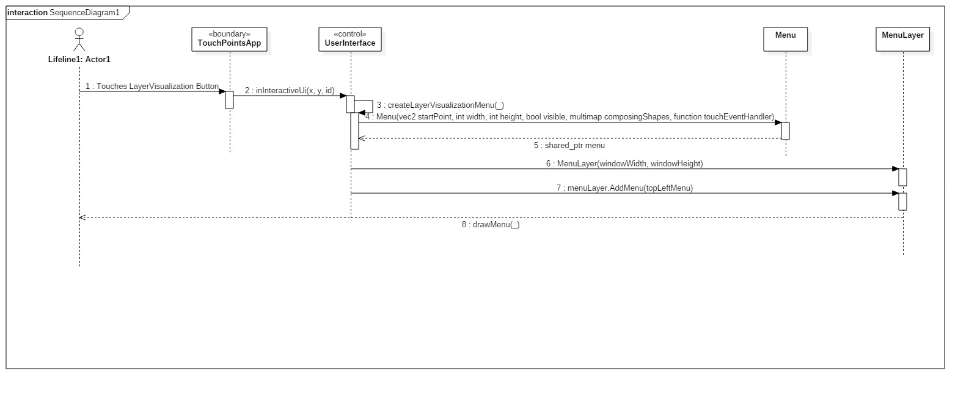

**Class Diagram**

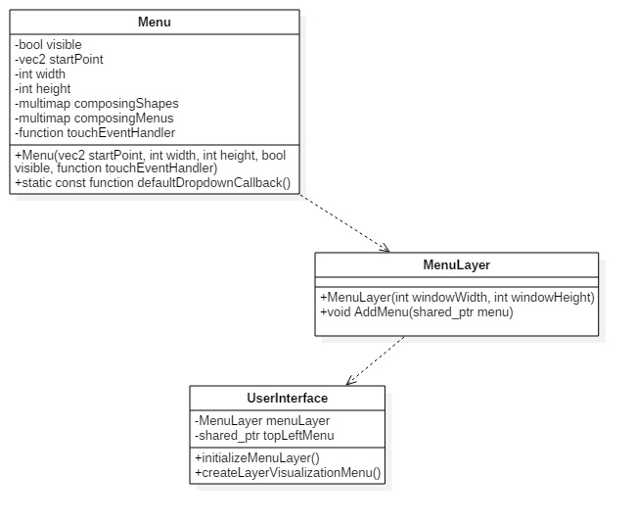

**Unit Test**

Sunny Day Tests

Test Case: UI and Drawing Still Work

Test Purpose: Ensure that the user can still use the Multi Touch to draw on the screen and interact with the UI menus after the layer visualization feature is rewritten

Test Setup:

⦁ run program

Test Output:

Layer Visualization drop down menu drawn correctly

Expected Output:

After testing all integrated devices, i.e. the Multi Touch, RealSense, Leap and Eyex can still contribute to drawing, the screen should draw correctly and the Layer Visualization Feature drop down menu should function properly.

**Integration Test**

Devices can still be used to draw in the application, i.e. the RealSense, Leap and Eyex can still contribute to drawing. The Layer visualization drop down menu functions properly when activated via Multi Touch

**Visual User Guide**

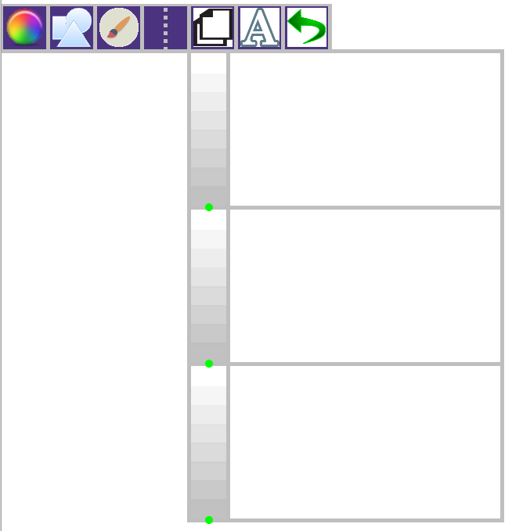

As seen above, the layer visualization feature drop down is being drawn properly.